**Set up Git Repository**

1. Create an organization in GitHub

Create a new Account in GitHub if you do not have already

1. Create a repository in GitHub

**Here are steps to do that:**

1. **Click on “New”**

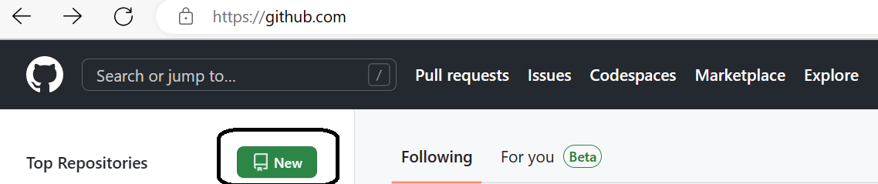

1. **Give Suitable Name to your Repository & Select Public/Private setting**

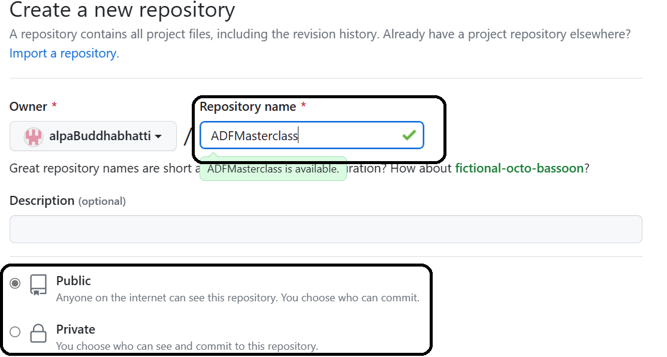

1. **Click on “Create Repository”**
2. **Now add dummy file. Just add test.txt file and commit your changes.**

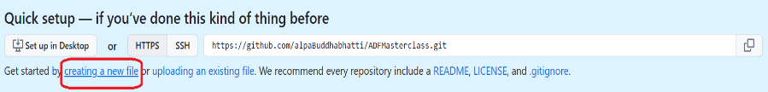

Finally, it will look like, So it is now available to use in ADF

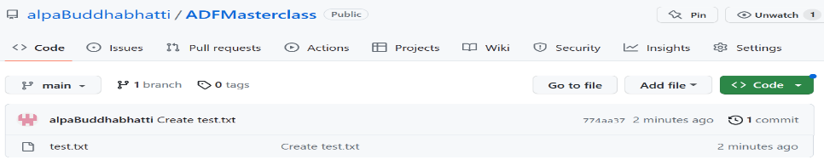

1. Go to ADF and set up Repo.

There are two different option you can see in ADF Portal as below

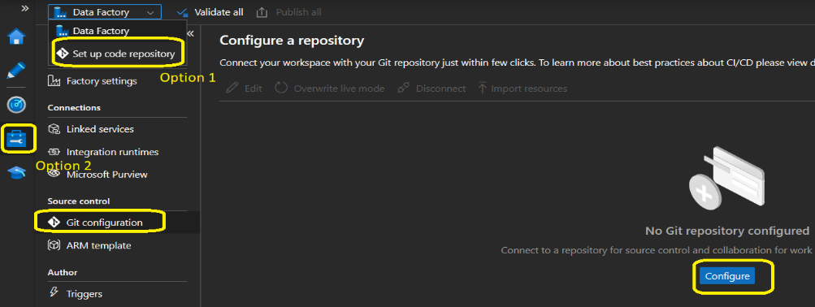

1. **Please go to “Configure” as shown in above**
2. **Set values as shown below and click on “Continues”.** Pop up will appear and ask to login your GitHub account to access repositories from your GitHub.

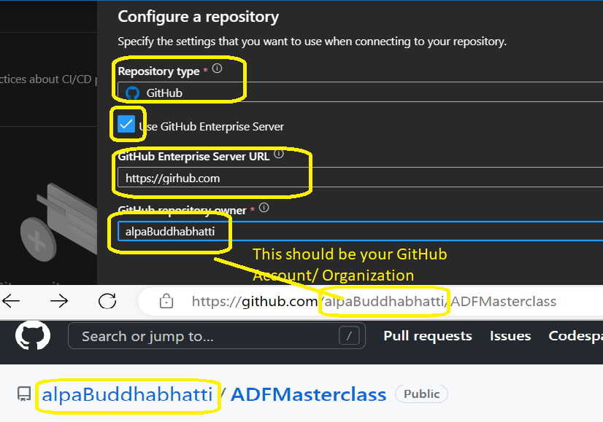

1. **Select options as below and click on “Apply”**

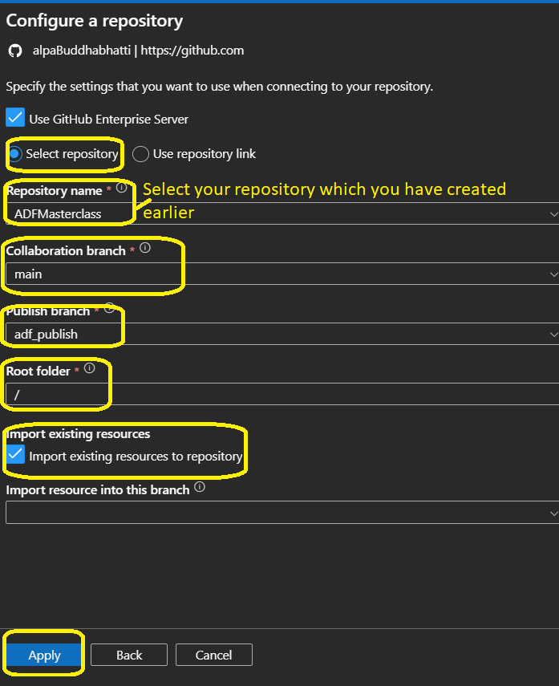

1. **Finally, you will see as below**

